Restaurant Rating Prediction

***Wireframe Documentation***

Homepage

First, we will land into the homepage where we will able to see the details of the application.

The social media link, developer details, motive of the applications are mentioned here.

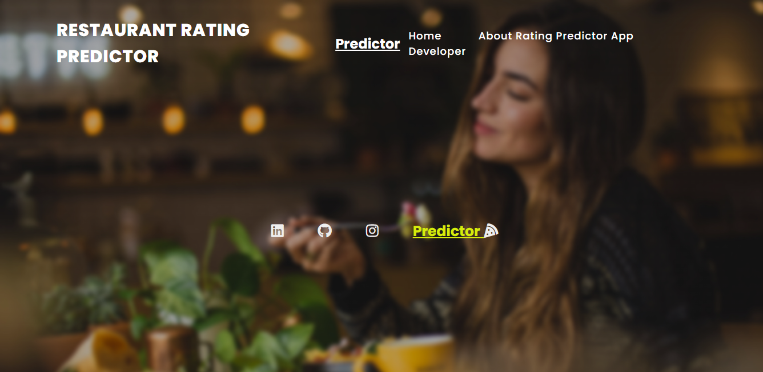

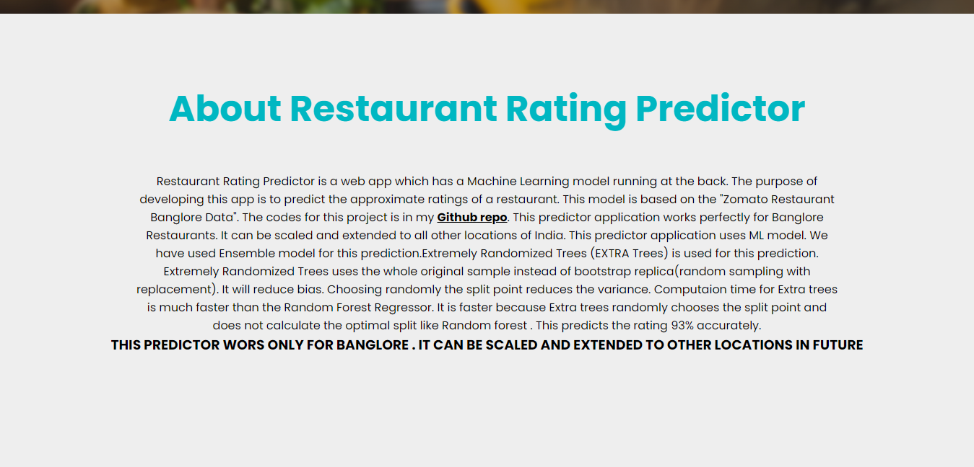

The User will able to see the Restaurant Rating Predictor Link. After clicking the link, it will be redirected to the main page.

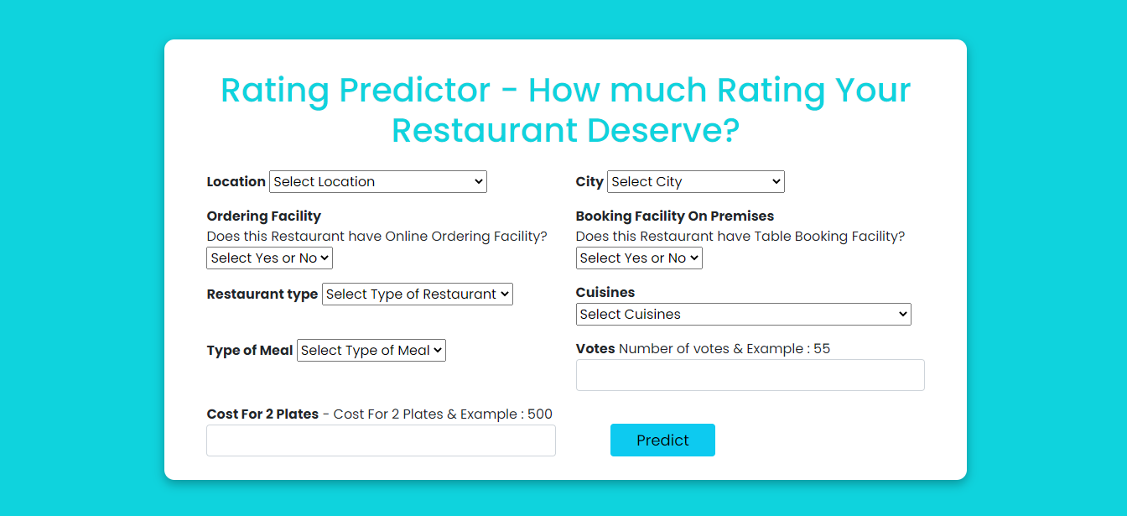

Based on User’s input, Rating Predictor system will provide rating to User on another page. A sample view result page is here,

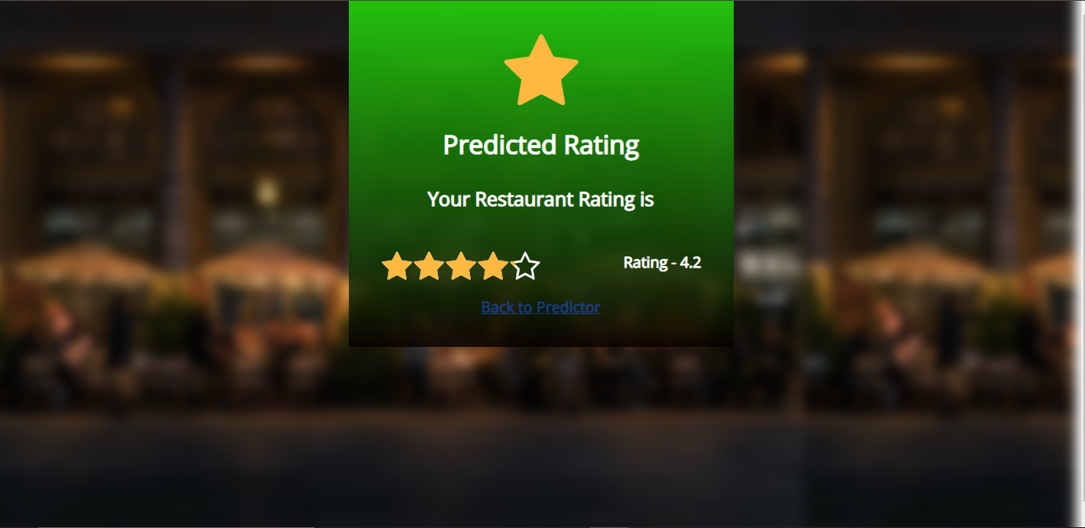

The sample pages are given below,

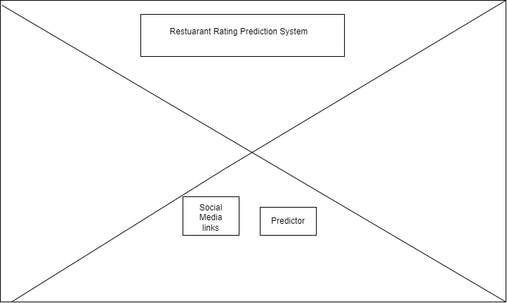

The **Crossed Sections** in above sample can be used for images of food & restaurants as background to give user a good experience.

